IL Gilt Inflation Sensitivity
Functionality Reference | FRTB SA MAR21.8b | 5 Feb 2026 Snapshot

1. What Does This Feature Do?
The inflation sensitivity calculation measures how much the USD market value of an Index-Linked (IL) Gilt position changes when breakeven inflation rises by 1 basis point across all maturities simultaneously. The result is a single number called GIRR_GBP_INFLATION reported in USD. It feeds directly into the FRTB Standardised Approach capital calculation as the GBP inflation sub-bucket sensitivity.

2. End-to-End Data Flow
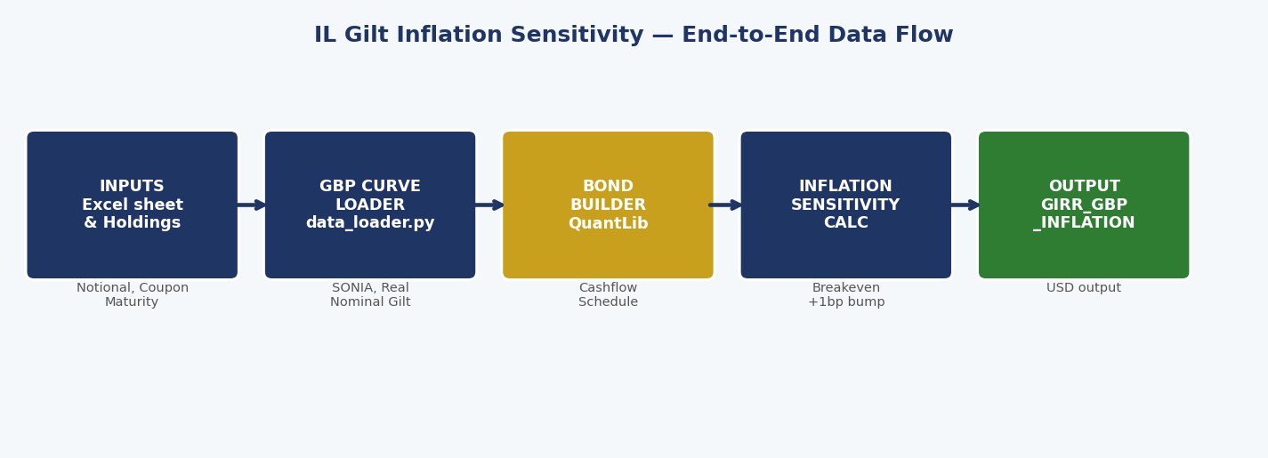
Figure 1 - Data flows from Excel inputs through the curve loader and bond builder into the sensitivity calc, outputting GIRR_GBP_INFLATION in USD.

3. Inputs and Outputs
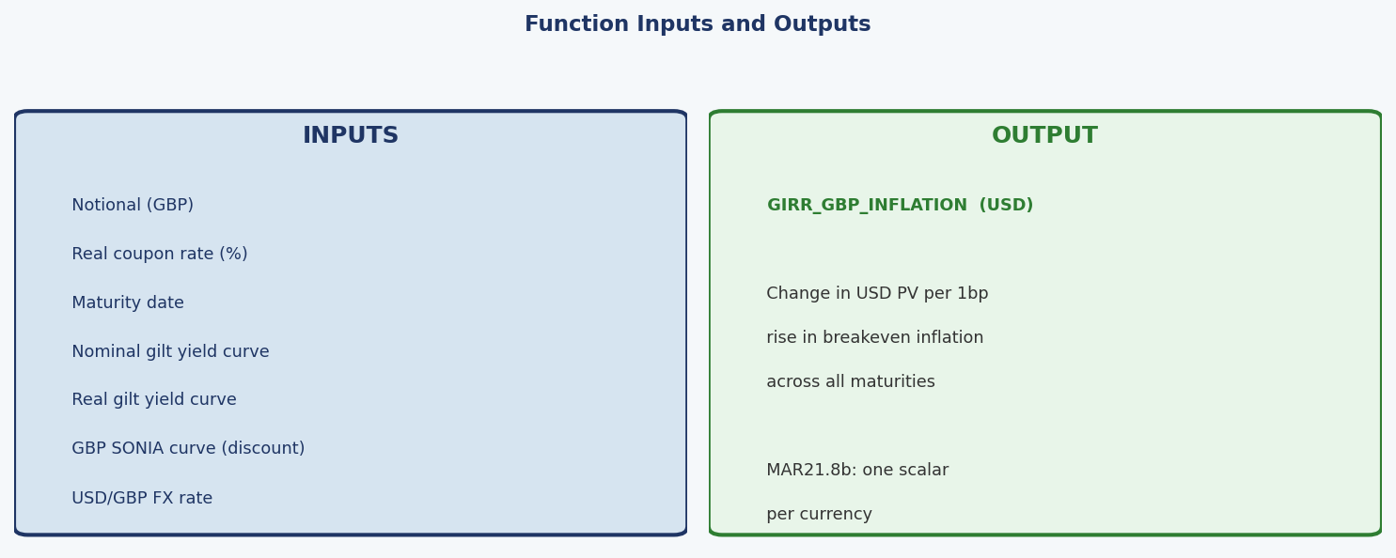
Figure 2 - All seven inputs (left) and the single output (right).

4. Where Each Input Comes From
Input | Source in Excel | Example Value
Notional (GBP) | Holdings sheet -> Quantity/Notional | 5,000,000
Coupon rate | Holdings sheet -> Coupon/Rate (%) | 1.25
Maturity date | Holdings sheet -> Maturity | 2040-07-22
Nominal gilt yield curve | GBP_Curves sheet -> UK Nominal Gilt Yield Curve | 4.60% at 10Y
Real gilt yield curve | GBP_Curves sheet -> UK Real Yield Curve | 0.95% at 10Y
SONIA discount curve | GBP_Curves sheet -> SONIA Rate | 3.95% at 10Y
USD/GBP FX rate | Market data snapshot -> USD/GBP column | 1.3645

5. Breakeven Inflation - The Core Input
At each cashflow date the code computes:
pi(t) = Nominal Gilt Yield(t) - Real Gilt Yield(t)
Both curves are read directly from the GBP_Curves sheet. The chart below shows the three curves for the 5 Feb 2026 snapshot. Breakeven rises from about 2.7% at 1 year to 4.7% at 30 years, reflecting structural pension fund demand for long-dated inflation protection.
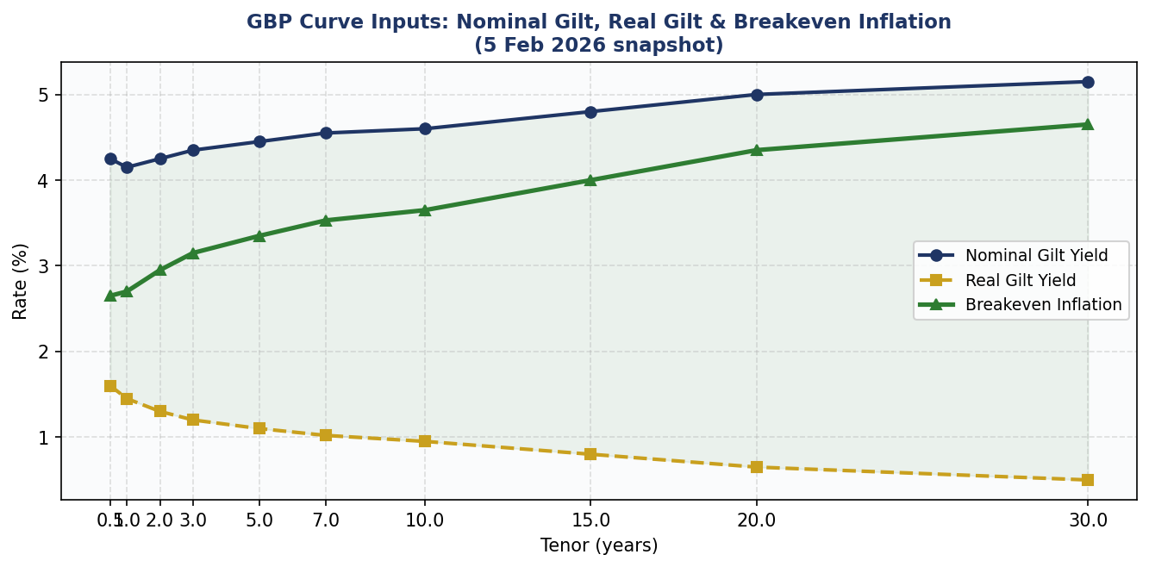
Figure 3 - Nominal gilt yield (blue), real gilt yield (gold) and implied breakeven inflation (green). The shaded area is the breakeven spread used in the calculation.

6. The Five Computation Steps
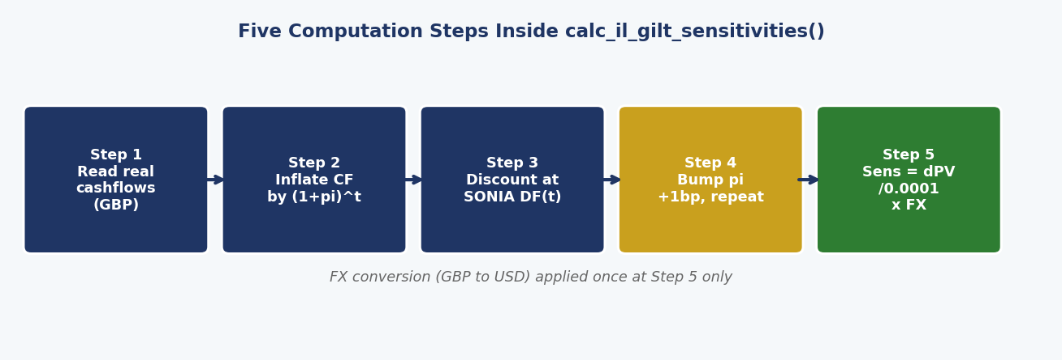
Figure 4 - The five steps executed for each IL gilt position.

Step 1 - Read real cashflows: QuantLib generates the bond cashflow schedule (coupons + principal) in GBP using the real coupon rate, maturity and Actual/365 day count. These are undiscounted raw amounts.
Step 2 - Inflate each cashflow to nominal: Each real GBP cashflow is multiplied by (1 + pi(t))^t where pi(t) is the breakeven inflation interpolated at that cashflow date. This converts the real cashflow to its nominal GBP equivalent.
Step 3 - Discount at SONIA: The nominal GBP cashflow is discounted using the SONIA discount factor for that date. Summing over all cashflows gives PV_base in GBP.
Step 4 - Bump breakeven by +1bp and repeat: Steps 2 and 3 are repeated with pi(t) increased by 0.0001 at every tenor. The SONIA discount curve is held fixed - only the inflation expectation moves. This gives PV_bumped in GBP.
Step 5 - Compute sensitivity and convert to USD: Sensitivity (GBP) = (PV_bumped - PV_base) / 0.0001. Multiplied by USD/GBP to give GIRR_GBP_INFLATION in USD. FX conversion is applied once here at the very end.

7. Key Design Decisions
- Nominal gilt - not SONIA - for breakeven: SONIA carries bank credit risk. Breakeven must use sovereign gilt yields on both legs so the credit component cancels. Using SONIA overstates breakeven by ~60-80bp.
- GBP notional throughout - FX only at the end: The bond is priced entirely in GBP. Applying FX at the end ensures that GBP discount rates are applied to GBP cashflows, not to USD-sized cashflows.
- SONIA still used for discounting: MAR21 requires SONIA as the GBP risk-free discount curve. Only the breakeven source has been corrected to use gilt yields.
- One scalar output per currency: MAR21.8b prescribes a single inflation sensitivity per currency with no term structure. The code sums across all cashflow dates into one number.
- All rates from Excel - no hardcoding: Nominal gilt, real gilt and SONIA rates are all read from the GBP_Curves sheet. To update market data, edit the Excel file only - no Python changes needed.

8. Output Reference
Output key | GIRR_GBP_INFLATION
Currency | USD (after USD/GBP FX conversion)
Sign | Positive = IL gilt holder gains when inflation rises
FRTB bucket | GIRR GBP inflation sub-bucket (MAR21.8b)

